Test Project Module 1
(Corporate Design)
WSC2013_TP40_MO1_actual_EN

Submitted by:
Thierry Herman BE
Susanne Moustgaard DN
Terkko Malm FI
Sathish Narayanan IN
Amy Soon SG
Wolfgang Toechterle IT

Contents
This Test Project proposal consists of the following documentation/files:
- Text Doc: WSC2013_TP40_MOD1_actual_EN
- WSC2013_TP40_MOD1_Folder containing:
  - image files: images
  - Font folder: Kristall Now Pro
  - Given text in file: TEXT_Module_Corporate_Design.rtf
  - QR Code in file: druckkunst.png
  - Bag Diecut in file: BAG_dieCUT.ai
  - Colour profile file: ISOcoated_v2_300_eci.icc, PSO_Uncoated_ISO12647_eci.icc

Introduction
From the lead typeface to the Apple Mac:
550 years of printing history at the Museum of Printing Arts Leipzig
De tipografia sobre Mac
550 anos de historia del Museum of Printing Arts Leipzig

The history of the “black art” is one of brilliant inventions, innovations rejected or developed and sudden radical change on a breathtaking scale. And yet it always remains a story about people. At the Leipzig Museum of Printing Arts, the human touch makes printing history come alive again: rare historical machines and printing presses are shown in action, enabling visitors to experience the art of printing with all their senses.

La historia del arte negro es una de las mas brillantes invenciones, innovaciones impulsadas por el desarrollo como si tuvieran un cambio radical en una escala incleible . Y recuerda siempre sobre la historia de las personas. En el Leipzig Museum of Printing Arts el toque humano hace de la historia de la impresion continuar vivas las maquinas raras e historicas y prensas de impresion son presentadas en accion, permitiendo a los participantes una experiencia de impresion en todos los sentidos.

The museum’s collection of around 100 working machines and press for historical casting, composing and printing techniques really brings the history of printing alive combining a museum and an active workshop, visitors still can experience printing process first hand. The Museum of Printing Arts also houses a handcraft book bindery, a workshop of a wood engraving and a unique collection of more than 4,000 different typefaces from European and oriental provenance. The Museum of Printing Arts is based in the former industrial quarter Plagwitz in a listed industrial building that has been in continuous use as a printing house since the early 20th century.

La coleccion del museo posee por lo menos 100 maquinas en plena funcion y prensas para lingotamento, composicion y tecnicas de impresion que hace renacer la historia de la impresion, combinando el museo de una oficina activa, los visitantes pueden experimentar de primera mano un proceso de impresion. El Museum of Printing Arts tambien cuenta con una encuadernadora oficial, una oficina de grabado en madera y una colecion unica de mas de 4000 tipografias de origen europeo y oriental. El Museum of Printing Arts esta localizado en el antiguo barrio industrial Plagwitz, en un edificio industrial protegido que fue utilizado como casa grafica desde o inicio del siglo 20.

Three special exhibitions per year focus on individual theme related to printing and all its various facets. The current exhibition, which runs until mid-May 2012 is entitled “From lithography to offset printing, the Kunstanstalt Carl Garte Leipzig and the collection of Hans Garte”. It shows extraordinary examples of multi-colour lithography and early examples of offset printing from the beginning of the twentieth century.

Tres exibiciones especiales por ano enfocadas en temas especificos relativos a la impresion y todos sus variados aspectos. La exposicion actual, que estara abierta a mediados de mayo de 2012, lleva el titulo de Litografia e impresion offset, Kunstanstalt Carlo Garte Leipizig es una coleccion de Hans Garte. El lleva al publico extraordinarios ejemplos de la litografia multicolores de impresion offset de inicios del siglo XX.

The Museum sees the future as lying in intelligent networking of print and Internet along the lines of “Augmented Reality” – with the difference that all the senses are addressed simultaneously at the Museum. When it comes to the media mix of the future, the Museum recommends occasionally taking a look back at the history of printing technology so as to understand the here and now better and actively use expertise from the past as a source of inspiration for the future.

El museo anticipa que en un futuro se encontrara en una red inteligente de impresion e internet a partir de la realidad aumentada – con una diferencia, todos esos sentidos tendran lugar al mismo tiempo en el museo. Cuando se ve venir la media del futuro, el museo nos remite al pasado de la tecnologia de impresion para que se pueda entender mejor aqui y ahora de manera activa utilizar la experiencia del pasado como fuente de inspiracion para el futuro.

Description of project and tasks
Descricion del proyecto y de las tareas

The Museum of Printing Arts needs to build an identity that will be used consistently through all its documents. Your job is to create this corporate identity; with colours, photos and illustrations, typefaces, etc. This will be applied to several promotional items including a Letterhead and Business Card, Entry Ticket and Shopping Bag.

El Museum of Printing Arts precisa construir una identidad visual que sera presentada en varios de sus documentos. Su trabajo e crear una identidad corporativa, con colores, fotos, ilustraciones, tipografias, etc. Esa identidad visual sera aplicada en muchas piezas promocionales , incluyendo papeleria y tarjetas de visita, tickets y bolsas de compras.

Throughout the whole project you should consider that the museum represents the art of letterpress printing. Due to this, some documents will be produced with this printing method. When you design remember some of the limitations of letterpress printing. Such as fine lines, large solids and halftone screens or the transparent quality of letterpress Ink.

Tenga en mente todo el tiempo que el museo es un icono de arte de impresion de letras. En funcion de esto, algunos documentos tiene que ser disenados segun el metodo de impresion . Cuando trabajar o disenar, recuerde siempre de algunas de las limitaciones de impresion letterpress, tales como lineas, solidos, o mejor tambien las cualidades de transparencia de las tintas de letterpress.

Therefore the client asked for a clean and straight forward approach. The Design must be forward-looking and modern. Must explicitly be "not conservative."

Ademas el cliente pide una linea mas limpia y moderna. El diseno debe ser de vanguardia y moderno. Mas explicitamente, no debe ser conservador.

Target audience Publico Objetivo

Individuals and families who are interested in history of the “black art” and related brilliant inventions.
Individuos y familias interesadas en historia de black art e identificadas con invenciones geniales.

Task 1: logo Tarea 1- logo

The Museum of the Printing Arts needs you to create a logo for the Museum. The logo needs to embody the ideas of printing and all its various facets. From a historical, technical, handcraft view, up to the beginning of the twentieth century.

El Museum of the Printing Arts necesita que usted cree un logo para el museo. El logo debe contemplar las ideas de impresion y sus muchas facetas. Desde una perspectiva historica, tecnica y artesanal empezando por el siglo XX.

- The logo should have a compact shape.
- It should be possible to use it for both offset and letterpress printing.
- The logo must include the complete name “Museum of Printing Arts Leipzig”.
- You must prepare the German version, too. “Museum für Druckkunst Leipzig”.
This version of the logo is the same design. This logo will be used in all the German language documents.
- The city name "Leipzig" is an important part of the Logo because of the existence of other similar museums in other cities.

- El logo debe tener un formato compacto
- Debe ser posible utilizar - tanto la impresion offset como letterpress
- El logo debe contener el nombre completo “Museum of Printing Arts Leipzig”.
- Usted debe preparar una version en aleman tambien “Museum für Druckkunst Leipzig”.

El nombre de la ciudad de "Leipzig" es parte importante del logo dado que existen museos similares en otras ciudades.

Technical specifications: Especificaciones tecnicas
Colours: Two versions of the same logo: a) 2 PMS colour b) CMYK
Colores – Dos versiones del mismo logo – a) 2 cores PMS b) CMYK

Include the name of the Pantone number with a colour swatch.
Incluya el nombre de los pantone con el numero y los nombres de los colores utilizados
Text for two separate logos with the same design: English Logo: Museum of Printing Arts Leipzig
German Logo: Museum für Druckkunst Leipzig
Texto para dos logos separadas con un mismo diseno -
Logo ingles - Museum of Printing Arts Leipzig
Logo aleman - Museum für Druckkunst Leipzig
Printing: Letterpress and offset printing
Impresion – letterpress e impresion offset

Trapping: 0.5 points
Images: Only vectorized images are allowed for the logo
Imagenes – solamente imagenes vectoriales son permitidas

You must deliver: Usted debe entregar:

- 1 final folder of your working files for archiving
- 1 carpeta final con sus archivos de trabajo para archivar
- 1 Illustrator (ai) file showing the English and the German logo in 2 PMS colours (Pantone Uncoated), as well as the English and the German logo in CMYK on the same Artboard (All 4 on same page)
- En un archivo de ilustrator 4 logos versiones en ingles y versiones en aleman – 2 en colores especiales (dos colores PMS – Pantone Uncoated), siendo una en ingles y otra en aleman, y dos logos en CMYK, siendo una en ingles y otra en aleman. (todos 4 en una misma pagina)

- 1 PDF/X-3:2002 file of your logo in CMYK (NO SPOT COLOUR INCLUDED)
- 1 archivo PDF/X-3:2002 con su logo en CMYK (NO PUEDE HABER COLOR ESPECIAL)

- 1 A4 printout, mounted on presentation board showing the two versions of the Logo (English and German) as well as the two colour Versions (PMS and CMYK). Display the used colour swatches in a colour chart.
- 1 copia impresa, montada en una plancha de presentacion con las dos versiones del logo (ingles y aleman) tambien las dos versiones de colores (PMS e CMYZ) de ambos logos. Incluir la leyenda de los colores utilizados en esta plancha de presentacion.

Task 2: Letterhead and Business Card
Tarea 2 / papel carta y tarjeta de visita

Required elements for both – letterhead and business card:
Elementos requeridos para los dos – papel carta y tarjeta de visita

Given text: (Texto Entregado)
Stiftung Werkstattmuseum für Druckkunst
Nonnenstraße 38
D-04229 Leipzig
Tel. +49 341 / 231 62-0
Fax +49 341 / 231 62-10
info@druckkunst-museum.de
www.druckkunst-museum.de

Logo: German version only (solamente una version en aleman)

Font: The museum owns the font family Kristall Grotesk. This font family must be used for the entire “given text” on the letterhead and business card.

Fuente – El museo posee una fuente de la familia Kristall Grotesk. Esa familia de fuente debe ser utilizada para todo el texto entregado, tanto en el papel carta y la tarjeta de visita

Technical specifications LETTERHEAD: ESPECIFICACIONES TECNICAS PARA EL PAPEL CARTA
Colours: CMYK
Trim size; A4 (297 X 210 mm)
Printing: offset printing
Bleed: 3 mm
ICC profile: PSO_Uncoated_ISO12647_eci.icc
Greyscale and colour images resolution: Only vectorized images are allowed for the letterhead
Solo imagenes vectorizadas

Technical specifications Business Card: Especificaciones tecnicas para la tarjeta de visita
Trim size business card: 85 x 55 or 55 x 85 mm tamano recortado

Design: Both side (front and back) Tiro y retiro
Printing: Letterpress
Colours: 2 spot colours
Bleed: 3 mm
Trapping: 0.5 points

ICC profile: PSO_Uncoated_ISO12647_eci.icc
Bitmap, grayscale and colour image resolution: Only vectorized images are allowed for the Business Card
Solo imagenes vectorizadas

- You must deliver: Usted debe entregar

- 1 Letterhead final composite PDF/X-3:2002 file (including bleed, crop marks and specified output profile)

- 1 archivo papel carta final compuesto PDF/X-3:2002 *Incluyendo sangria, marcas y el perfil de salida especificado
- 1 Business Card final composite PDF/X-3:2002 file (including bleed, crop marks and specified output profile)
- 1 archivo compuesto de la tarjeta de visita PDF/X-3:2002 (Incluyendo sangria, marcas y el perfil de salida especificado)
- The letterhead and business card trimmed and mounted onto a single presentation board.
- El papel carta y la tarjeta de visita cortada y montada en un carton para presentacion
- 1 A4 printout of your Business Card (front and back) with ONLY crop marks and bleed marks
- 1 impresion en A4 de su tarjeta de visita tiro y retiro con solo marcas de corte y marcas de sangrado
- 1 A3 printout of your Letterhead with ONLY crop marks and bleed marks
- 1 impresion del papel carta montado en A3 solo con marcas de corte y marcas de sangrado
- 2 final folders for archiving and printing (including PDF, native files, fonts,)
- 2 carpetas para archivar e imprimir * incluya PDF, archivos nativos, Fuentes.

Task 3: Entry Ticket Boleto de entrada

Create a one colour, one-sided entry ticket to be given at the entrance to all visitors. The client would like to show a consistent design throughout all documents. Tradition and modernity are important. The given serial number needs to be included in part 1 and part 2 of the ticket.

Cree a un color, por un solo lado, un tiquete que servira para la entrada de todos los visitants. El cliente le gustaria de presenter un diseno coherente con todos los documentos. Tradicion y modernidad son importantes. Los numeros de serial proporcionados son importantes y se necesitan incluir en la parte 1 y 2 del tiquete.

Required elements Elementos Requeridos

Given text : TExto entregado
Between technology and art
Experience type casting, type setting
and printing processes in a working museum
Nonnenstrasse 38, D- 04229 Leipzig
Phone +49 (0) 341-231 62 0
www.druckkunst-museum.de
Mon - Fri 10 -17, Sun 11 -17, closed Saturday

Serial number use : 247398

Logo: English version only (1 PMS colour)
Design: Single sided un solo lado

Font: no specification
Serial number: To be on both parts of the ticket (on part 1 and part 2) Numero SERIAL en la parte 1 y 2

QR-Code:
minimum size: 20 x 20 mm, must be 100% colour Tamano minimo 20x20 mm. Color tal cual

Flie: druckkunst.png


Technical specifications: Especificaciones Tecnicas
Printing: Letterpress
Colours: 1 PMS colour. Use Pantone uncoated numbers.
Bleed: 3 mm if needed
ICC profile: PSO_Uncoated_ISO12647_eci.icc
Trim size: 150 x 60 mm
Perforation: to be indicated with a straight vertical line 45 mm from the left
Perforacion: Debe ser indicada con una linea recta vertical a 45 cms de la izquierda
Images resolution: Only vectorized images are allowed for the Entry Ticket
Solamente imagenes vectoriales
45 mm ---->
Part 2
Part 1

You must deliver: Usted debe entregar
- 1 final composite PDF/X-4:2010 file (including: bleed, crop marks, and specified output profile). The perforation and serial number must be placed on a separate layer in the PDF file.
- 1 archivo final PDF compuesto PDF/X-4:2010 incluyendo: sangria, marcas de corte, y perfil de color especificado. La perforacion y el numero serial deben ser colocados en un layer separados dentro del archive PDF
- 1 printout of your composition trimmed and mounted on 1 A4 board to present your design.
- 1 copia impresa de su composicion cortada y montada en un carton A4 para presenter su diseno
- 1 A4 printout of your Ticket with ONLY crop marks and bleed marks
- 1 A4 impreso de su tiquete con solo marcas de corte y marcas de sangrado
- 1 final folder for archiving and printing (including PDF, native files, fonts)
- 1 archivo final para archivar e imprimir (incluyendo PDF, archivos nativos y Fuentes)

Task 4: Shopping Bag Bolsa de Compras
Create a full colour (CMYK), two-sided shopping bag for the museum shop. It’s a redesign of an existing bag therefore, the size of the bag and die cuts are given. Due to the many international visitors the German and the English Logo version must be represented on the bag. The customer requires you to use a spot varnish on both versions of the Logo.

Cree a full color (CMYK) 2 caras de una bolsa para la tienda del museo. Esto es el rediseno de una existente el tamano de la bolsa y el troquel ya esta listo, como hay muchos visitants extranjeros es necesario colocar el logo en la version ingles y aleman. El cliente quiere que tu coloques el barniz encima de los dos logos.

Required elements Elementos Requeridos

Given text: Texto Proporcionado
Between technology and art
www.druckkunst-museum.de

Logo: Both English and German Version with spot Varnish
The indication of the varnish must be named as “Varnish”, as a spot colour and it must be 100% black

Font: no specification
Fuentes no especificadas
Images: Minimum 2 images must be used, you are free to use more.
Imagenes: Minimo 2 imagenes deben ser usadas, usted es libre de usar mas.

DieCut Troquel
You must use the given Die Cut “BAG_dieCUT.ai”. An example of the printed bag will be given to each competitor.

Technical specifications: Especificaciones Tecnicas
Printing: offset
Colour: CMYK + spot varnish
Bleed: 3 mm
Trapping: 0.5 points
ICC profiles: ISOcoated_v2_300_eci.icc

Trim size: design on the given Die Cut. Disenar sobre el troquel proporcionado
Greyscale and colour image resolution: 262 to 350 PPI at 100% in the design (Layout)
Bitmap image resolution: 800 to 1200 PPI at 100% in the design (Layout)

You must deliver Usted debe entregar
- 1 final composite PDF/X-3:2002 file (including bleed, die cut and specified output profile, colour bars for CMYK + varnish at 100% black)
- 1 Archivo final compuesto PDF/X-3:2002 ( incluyendo sangrado, troquel, el perfil de salida solicitado, las barras de color para CMYK mas el varnish a 100 % DE NEGRO
- 1 printout of your composition to fit on A3 with the varnish on top of the design (the varnish area needs to be 20% transparency)
- 1 Impresion de su composicion cortada sobre A3 con el barniz sobre el diseno (El area de barniz necesita ser simulada con un 20% de transparencia)
- 1 printout of your composition to fit on A3 and mounted on one board for presentation without the varnish.
- 1 impresion de su composicion cortada y montada sobre A3 sobre un carton para la presentacion con el barniz
- 1 final folder for archiving and printing (including PDF, native files, fonts, linked images, ICC profile)
1 Carpeta para archivar e imprimir (incluyendo PDF, archivos nativos, Fuentes, imagenes vinculadas, y perfil de color).

Instructions to the competitor
About image marking for all tasks:
The final resolution, colour mode and file formats of your images will be evaluated in the press ready PDF files. The JPG file format is NOT ACCEPTED for images files (outside of the PDF); only the following saving format files are acceptable: .tif / .eps / .ai / .png

Create a folder on your Desktop called YY_MOD_X (where YY represents the number of your workstation and X your Last Name). This folder must include the following subfolders “Task1, Task2, Task3, Task4”. Those subfolders contain two folder with:

- Original folder: it should contain all the files used for the development of your project, properly organized (fonts, links, etc.).
- Final folder: it should contain all the files you are supposed to deliver to print as required in the tasks (PDF, etc.).

Any file saved out of its respective folder WILL NOT BE EVALUATED.

Images must not be embedded in Adobe Illustrator or InDesign

The colour mode and file formats of your images will be evaluated in the press ready PDF files; EXCEPT in Task 4 Greyscale and colour image resolution will be evaluated in the used software such as InDesign or Illustrator.

Equipment, machinery, installations and materials required
No specific equipment required.

Marking scheme
A2 |  |  | 2,00
 | Ideas and originality | 1,00
 | Understanding the target market | 0,50
 | Unity and relationship between all tasks | 0,50
B2 |  |  | 8,00
 | Logo inline with clients brief | 1,00
 | Quality of the visual composition of the Logo (aesthetic appeal and balance) | 1,50
 | Visual Impact & Communication effectiveness (Letterhead and Business Card) | 1,00
 | Visual Impact & Communication effectiveness (Ticket Design) | 0,50
 | Visual Impact & Communication effectiveness (Shopping Bag Design) | 1,00
 | Quality of the typography for all tasks | 1,00
 | Quality of the colours for all tasks | 1,00
 | Quality of the mounted presentations and the printouts | 1,00
C2 |  |  | 4,00
 | Resolution of images in Layout as specified in T1, T2, T3, T4 | 0,75
 | Colour mode of the Logo as specified in all tasks | 0,75
 | Image or element dimensions as specified | 0,75
 | Final dimensions of layout as specified in task 2 and 3 | 0,50
 | All required text is present in all task | 0,50
 | All required elements are present in task 2, 3 and 4 | 0,75
D2 |  |  | 2,00
 | Mounting printouts on board for presentation | 1,00
 | Supply of printouts all tasks | 1,00
E2 |  |  | 4,00
 | Bleed value applied in PDF as specified in the task | 0,75
 | Trapping value applied in the file as specified in the task | 0,75
 | Overprinting applied in PDF as specified in the task | 0,50
 | Spot and CMYK colours used in PDF file as specified in the T1,T2,T3 | 1,00
 | Color, varnish and dieCut in PDF as specified in task 4 | 0,50
 | Naming of spot colour PMS U in T1, T2 and "Varnish" in task 4 | 0,50
F2 |  |  | 5,00
 | Correct naming and all files saved in the correct format specified in the task | 1,25
 | ICC profile applied in PDF file as specified in the task | 1,25
 | Saving in a specified PDF format as required in the task | 1,50
 | Final production folder saved as required in the task | 1,00

Total = 25 marks per module (Objective 15 + Subjective 10)

APPENDICES
Text
Images
QR-Code
Preview Shopper model
DieCut

Task 1: logo

Museum of Printing Arts Leipzig
Museum für Druckkunst Leipzig

Task 2: Letterhead and Business Card

Stiftung Werkstattmuseum für Druckkunst
Nonnenstraße 38
D-04229 Leipzig
Tel. +49 341 / 231 62-0
Fax +49 341 / 231 62-10
info@druckkunst-museum.de
www.druckkunst-museum.de

Task 3: Entry Ticket

Between technology and art
Experience type casting, type setting
and printing processes in a working museum
Nonnenstrasse 38, D- 04229 Leipzig
Phone +49 (0) 341-231 62 0
www.druckkunst-museum.de
Mon - Fri 10 -17, Sun 11 -17, closed Saturday

Task 4: Shopping Bag
Between technology and art
www.druckkunst-museum.de

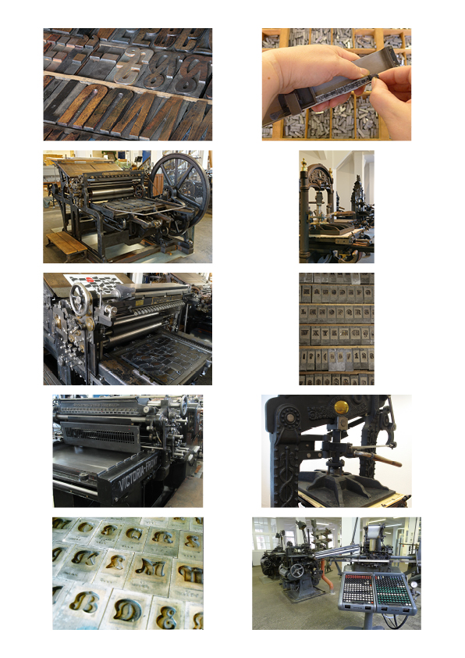
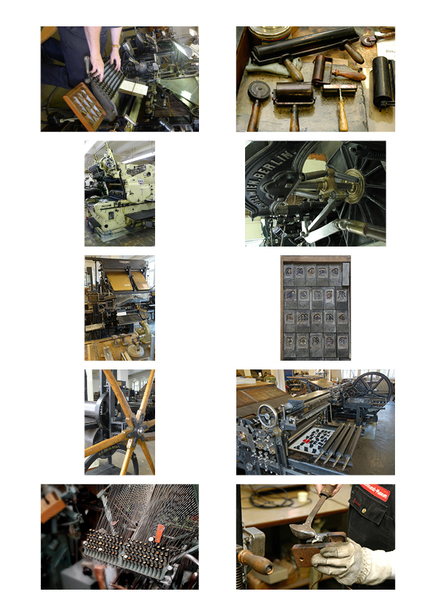
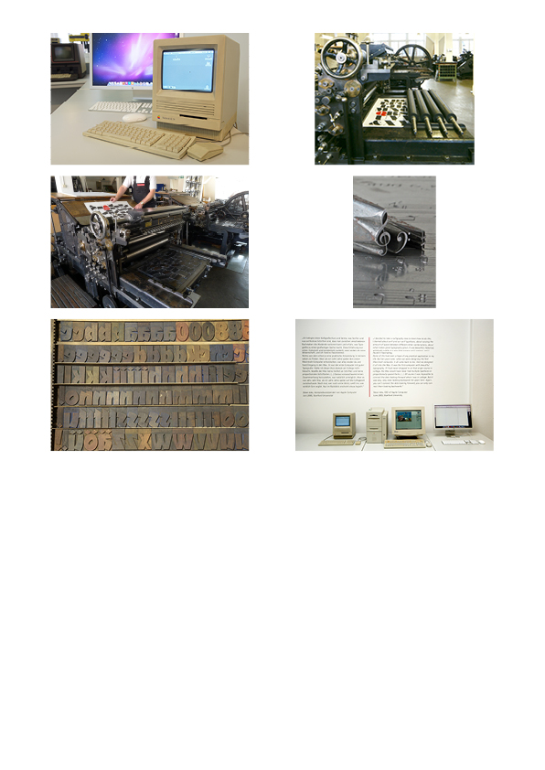



QR-Code: minimum size: 20 x 20 mm
File: druckkunst.png

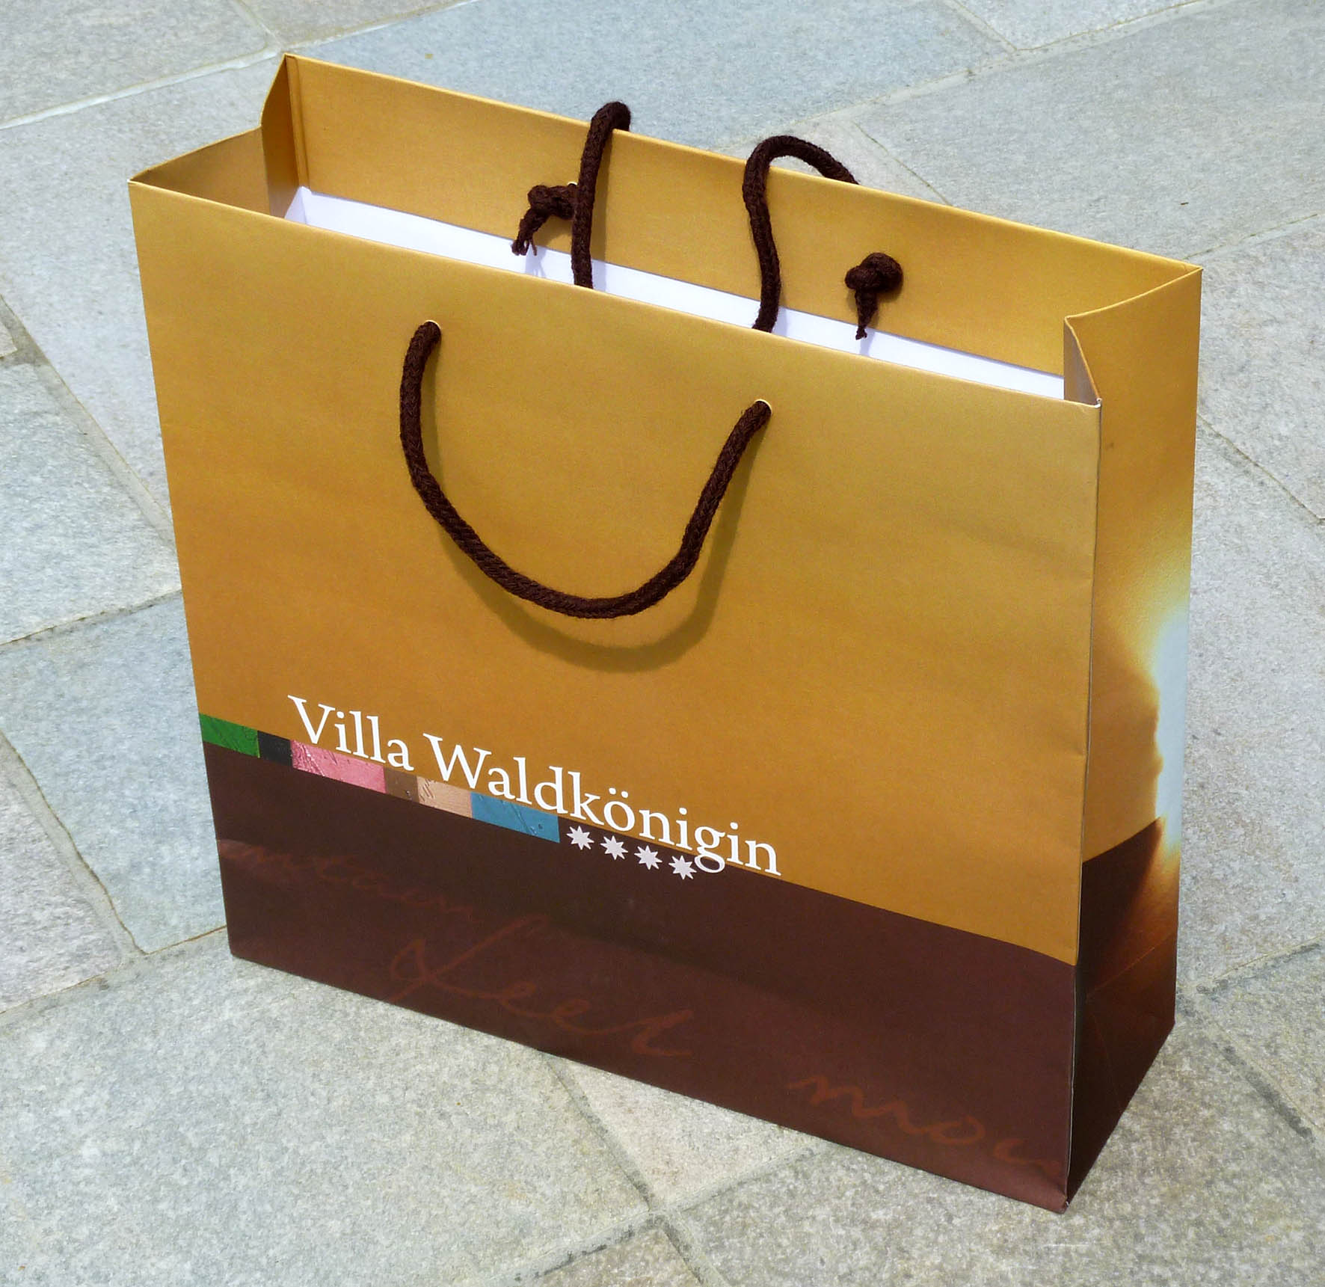

Example of a shopping bag with the given DieCut

given DieCut

